

**An Independent Project Report**

**submitted in partial fulfilment**

**of the regulations governing**

**the award of the**

**B.Sc. (Hons) in Computing, Year 2**

**Title: Mobile-Application EasyBook –**

**Online Restaurant Reservation System**

**LIEW WEI JUN**

**1001955444**

**Institute of Computer Science and Digital Innovation**

**UCSI University**

**[January, 2021]**

#### Authorship Declaration

Except where reference is made in the references, this report contains no material published elsewhere or extracted in whole or in part from a dissertation or report presented by me for another degree or diploma.

No other person’s work has been used without due acknowledgement in the content of the report.

|  |  |
| --- | --- |
| Signature: _LIEW WEI JUN___  [LIEW WEI JUN] | Date:__16/2/2021___ |

**Acknowledgement**

With deepest gratitude and appreciation, I humbly to give thanks for to people who, with all they can, helped and guided me in completing this study as possible.

To my parents, for their unending love and respects, for providing all my needs financially and morally, for their patience and understanding during my tiring days that I can’t help them in chores, for their never fading advices and for being there for me no matter what.

To the institution where I’m studying, UCSI University, where I am continuously growing as a Bachelor of Computer Science in Mobile Computing & Networking student and to institution’s library for giving us informative, useful resources and knowledges helped in completing this study.

To my supervisors, Dr. Javid and second marker, Assistant Professor Ts. Kasthuri of this study who shared their knowledge and experience to keep on molding me into a better person. I am extending my warmest thanks to both of them, with all they can, share everything that they know, and keep on inspiring, mand motivating me.

To all my friends, for the happiness and for being there to support me and to comfort me whenever I have difficulties during completing this study. I thank them for the friendship for being my companions whom I can share my laughter and sorrows with.

**Table of Content**

**Chapter 1: Introduction**

1. **Abstract………………………………………………………………………………..**
2. **Introduction…………………………………………………………………………..1**
   1. **Problem Statement…………………………………………………………..3**
   2. **Aim……………………………………………………………………………4**
   3. **Objectives…………………………………………………………………….4**
   4. **Justification…………………………………………………………………..5**
   5. **Scope………………………………………………………………………….5**
   6. **Constraints and Assumption………………………………………………..5**
   7. **Resources……………………………………………………………………..6**
   8. **External Bodies Involved……………………………………………………6**

**Chapter 2: Literature Review**

1. **Background……………………………………………………………………………**
   1. **Literature Review……………………………………………………………7**
   2. **Discussion and Comparison…………………………………………………8**
   3. **Similarities and Differences…………………………………………………9**

**Chapter 3: Research Methodology**

1. **Method………………………………………………………………………………….**
   1. **Approach and Deliverables…………………………………………………12**
   2. **Traditional SDLC…………………………………………………………...12**
   3. **Incremental SDLC…………………………………………………………..15**
   4. **UML Diagram……………………………………………………………….16**
   5. **Use Case Diagram…………………………………………………………...17**
   6. **Activity Diagram……………………………………………………………18**
   7. **WBS Diagram……………………………………………………………….19**
   8. **Milestones……………………………………………………………………20**
   9. **Gantt Chart………………………………………………………………….21**
   10. **Project Plan………………………………………………………………….22**
   11. **Research Data Gathering and Analysis……………………………………23**
   12. **Hypothesis………………………………………………………………….. 25**

**Chapter 4: Testing**

1. **Testing………………………………………………………………………………….**
   1. **Integrating Testing………………………………………………………….26**
   2. **Product Testing……………………………………………………………..30**
   3. **User Acceptance Testing……………………………………………………31**

**Chapter 5: Prototyping Interface**

1. **Prototype…………………………………………………………………………….35**
   1. **Login and Register Dashboard…………………………………………….35**
   2. **Home Dashboard……………………………………………………………36**
   3. **Menu Page…………………………………………………………………..37**
   4. **Food Detail Page…………………………………………………………….38**
   5. **Profile Page………………………………………………………………….38**
   6. **Loyalty Promotion Page…………………………………………………….40**
   7. **Reservation Section…………………………………………………………42**
   8. **Firebase Databases Display…………………………………………………46**
   9. **Firebase Authentication…………………………………………………….46**
   10. **Firebase Cloud Database……………………………………………………47**
   11. **Member Collection………………………………………………………….47**
   12. **Menu Collection……………………………………………………………..47**
   13. **Loyalty Promotion Collection………………………………………………47**
   14. **Table Reservation Detail Collection……………………………………….48**
   15. **Reservation Detail Collection………………………………………………49**
   16. **Order Detail Collection……………………………………………………..49**

**Chapter 6: Conclusion and Discussion**

1. **Conclusion……………………………………………………………………………..**
   1. **Conclusion…………………………………………………………………...50**
   2. **Future Development………………………………………………………...50**
   3. **Contribution of Society……………………………………………………..50**
2. **References…………………………………………………………………………...51**
3. **Appendix……………………………………………………………………………….**
   1. **Turnitin Report……………………………………………………………..55**
   2. **Variance Data of Collection………………………………………………..56**
   3. **Survey Questionnaire……………………………………………………….58**

**Title: Mobile-Application EasyBook – Online Restaurant Reservation System**

**Chapter 1: Introduction**

**Abstract**

Since the explosive growth of advanced technology, more and more people start to adopt the technology into their daily life to make their life easier. This project is going to develop an online restaurant reservation system that allows the customer to directly interact with the restaurant’s staff about their needs and order. By providing this reservation system, the restaurant and customers will get the optimize food online reservation and booking experience. Besides, this system introduced a restaurant loyalty program that allows the user to accumulate the rewards point and redeems the gift/ voucher/ instant cash rebate. This project has proposed to make online booking methods easier and more convenient. This project is carried out in an area around UCSI University.

**1.0 Introduction**

**History of web pages**

World Wide Web or generally “the Web” is a set of pages that shows the content related to a topic and those pages can be accessed through Web Browser with an Internet (Christensson, P., 2006). The Web is developed in the early 1989s by ***Tim Berners-Lee*** and it allows the user to open file sharing, information transformation, and exchange resources on the Web. Web history contains four generations, Web 1.0 is the webpage that only contains the information of a thing. It is considered to be a read-only web and displays information for businesses to customers which allowed them to query information and read the content only (Aghaei, S., 2012). Next generation, which is Web 2.0. Web 2.0 provides more interactions and content creation to the users and also known as the “web of communication”. It evolves from the read-only web page to read-write web and was invented by Dale Dougherty in 2004. Web 2.0 allows the web to interact in bi-directional and the user grants the ability to upload and download file resources online. Besides, social media, blogs, atom, or RSS (Really Simple Syndication) have been arises which is the functionality provided by Web 2.0 (Mata, F., 2014). Mobile web-application is coming into play since Web 2.0 was invented.

Web 3.0, which started to implement in 2014, provides a new interactive way to the user, namely is a read-write-execute web page. Web 3.0 can accept higher speed internet bandwidths to perform some artificial intelligent task, virtualization tools, etc. Web 4.0 is still an idea in progress and does not have any clear description of how Web 4.0 can do, Web 4.0 is believed to introduce more interaction between humans and machines and eventually might achieve action like mind-controlled application. Machines are believed to read the contents of the web, react to the contents, and reflect it to humans (Aghaei, S., 2012).

**Mobile user statistic**

According to Internet World Stats (Internet World Stats, 2020), Internet users on 30 Sept 2020 comprises 4.929 Billion and have a 63.2 percentage of over 7.796 Billion population in the world. Comparing the growth in the year 2000 to the year of 2020 has increase about 1266 percentage which is very massive in amount. This statistic shows that the Internet has been occupied human daily activities and people use the Internet to make their tasks complete in a simple manner. Mobile devices are also commonly used in Malaysia. Statista Research Department published an analysis report that shows the number of smartphone users in Malaysia has reached 30.41 million while the population of Malaysia is only 32.7 million in the year 2020 (92% of mobile users in Malaysia) (Ward H., 2020). This statistic report shows that mobile web application and also the mobile native application is a popular frequently used software on mobile site and Malaysians spend around 7.5 hours per day on the Internet, 2.45 hours on social media which they spend almost half a day on mobile phone and the Internet.

In 2017, smartphone users have occupied over 50% human population in the world and are expected to have around 6.1 billion users in 2020 (Kuo-Lun Hsiao, Yu Shu, Tien-Chi Huang (2017)). Both Google Play Store and Apple App Store achieved a total of downloaded apps are around 76 billion and 30 billion respectively. Nowadays, people using smartphones everywhere to contact friends, surfing the Internet, and browse information, File management, entertainment, etc.

Mobile Application is a software package installed in the smartphone that provides several functions for users to perform the task their need. Besides, the mobile application is a tool that is inexpensive, most compatible with almost every smartphone including entry-level phones. People use the mobile application to perform daily tasks for example chatting with friends, make reservation orders, getting online information everywhere, etc. and it shortens the distance of the human relationship (Islam, Dr. MD Rashedul & Mazumder, Tridib. (2010)).

**Flutter**

Flutter is a mobile application language framework based on Dart programming language. It has many features and provides an easy implementation layout to build a mobile native application (Idan Arb & Al-Majdi, 2020). Flutter is unique in that it relies on the device's OEM widgets instead of consuming web views. Each view component in Flutter is rendered using its own high-performance rendering engine. This allows higher a chance to build applications that are as high-performance as native applications can be. Flutter uses a component named widget to display the screen layout and the order of rendering the widget is by flex block design layout.

The hot reload feature provided by Flutter is named as Stateful hot reload. It is also the major factor for boosting the development cycle. Stateful hot reload is implemented by sending the updated source code into the running Dart Virtual Machine (Dart VM) without changing the inner structure of the application, only the component with the state changes will be rebuilt and rerender during development time. This will highly save the time consumed during developing the application (Karczewski, 2020).

**1.1 Problem Statement**

**Problem 1: There are very few restaurants that adopt an online reservation booking system. The customer is not preferred to use the online reservation system in Malaysia.**

The majority of the Malaysians do not frequently make a reservation online (Ali M. Shah, Syed Zeeshan Zahoor, Ishtiaq Hussain Qureshi., 2019). They are more willing to book a table using the phone contact method because they felt unsafe while online item stores their private information and might be sold to third-party.

One major drawback of these websites' reservations is known as perceived risk. The uncertainty in these websites is that they do not allow the customer to direct contact with the restaurant’s owner to tell out their condition. Besides, the performance risk will be the major considerable reason for the application. The customers might lose their reservation booking details on the website (Kleijnen, M., De Ruyter, K., and Wetzels, M. (2007)) due to network issues, server down service, and thus the restaurant is not able to receive the booking and prepare for it (Gerber, C., Ward, S. and Goedhals-Gerber, L., 2014.).

**Problem 2: There are very few restaurants that provide relevant loyalty programs to consumers.**

Based on the restaurant loyalty system research, it is found that a restaurant that providing the loyalty system to the customer will be one of the motivations to encourage the customers to visit the restaurant again. Based on the third-party online reservation website showed in table1, those websites do not provide a loyalty system to the customers. The website only provides the services such as viewing table layout, menu details, and offer booking service.

According to the Oracle Industry Connect report (Yasuda, G., 2018.), there is a huge cognitive recognition error between the consumer and the restaurant operators. In the report, 50% of the restaurant operators state the consumer has partially or fully participate in the loyalty program offered by them, however, there is only 27% of the consumers agree with the statement. Besides. Only 27% of the consumers agree that the loyalty program offered by the operators is relevant. To enhance the restaurant loyalty program to the consumers, the restaurant operators are required to design the program according to the customer preferences and consumption habits.

**1.2 Aim**

This project is to implement a web-based application to allow the consumers to direct making reservations to the restaurant.

This project aims to design and develop a mobile booking application Easybook for reserving, booking, and customizing your favourite dishes. Besides, this application allows enhancing the strength of the link between the customers and the restaurant operators by providing a relevant loyalty program to the customers to increase the loyalty of the user.

**1.3 Objectives**

**Objective 1:** To identify the strengths and differences of the online restaurant reservation system’s features.

**Objective 2:** To design an online restaurant reservation booking system to replace the traditional reservation (pen and paper).

**Objective 3:** To develop a clear and easy use system for the customer.

**Objective 4:** To evaluate the performance of loyalty programs inside the online reservation system.

**Objective 5:** Planning to integrate all the functions mentioned into a mobile application.

**1.4 Justification**

The purpose of this study was to increase the connection link between the customers and the restaurant operators by allowing the customers direct contact with the restaurant staff through the system. The restaurant operators can know the needs of the customers and do prior preparation for them. By introducing the loyalty system inside the application will enhance the customer loyally to the restaurant and revisit the restaurant. According to Lim’s paper, the result shows the significant relationship between the loyalty system with the restaurant's annual sales (Lim, E., Ooi, C., Ooi, S., Ooi, Y. and Tan, M., 2014). By introducing this system, it is believed that will benefits and bring convenience to the customer as well as the restaurant operators.

**1.5 Scope**

This project will be covered in the Malaysia area. This project required 7 months to completely develop the project from planning until the deployment phase. At the beginning of the first two months, the project should be properly planned, and the relevant project background research will be done. After the project planning, requirement gathering phase will be conducted by surveying with the target group to obtain the data. Project requirement details and data analysis will also be done within the project planning and the design phase. This project will spend one month to design the system layout and functionalities to make a clear system vision and easy to implement. The implementation phase of the project will take around 2 months. Last but not least is the testing and deployment phase.

**1.6 Constraints and Assumptions**

This project will not develop on any web server or large high-spec physical server. This project will only use a normal PC as the based server to the application. Besides, this project requires every customer to own a smartphone or any devices that can be connected to the Internet in order to make the reservation and browse the booking details.

There are still many restaurants using the old traditional booking method (pen and paper) in Malaysia. They might not have the interest in adopting the system in their restaurants.

Another constraint of this project is the user account password will not be encrypted with any complex hashing algorithm.

Assumption of this project:

1. All users are assumed to own a mobile device to access the application.
2. All users are assumed to have basic knowledge of using mobile applications through mobile devices.

**1.7 Resources**

**1.7.1 Hardware**

**Computer:** A fully functional computer is compulsory for this project as it is needed to design the prototype of the proposed mobile app, and writing documentation.

* **Model: MacBook Pro (13-inch, 2013)**
* **Processor: 2.4 GHz dual-core Intel Core i5 processor**
* **OS: macOS Catalina 14**
* **Memory: 8 GB 1600 MHz DDR3**
* **Graphics: Intel Iris Graphic**

**1.7.2 Software**

* **Microsoft Word**
  + Microsoft Word is used to write the project report and research findings.
* **Microsoft Project**
  + Microsoft Project is used to generate the Gantt chart diagram and project plan
* **Brave Browser**
  + Browser is used to search for relevant journal research
* **Visual Paradigm Online**
  + A tool to construct UML diagram, ERD diagram, etc.
* **MongoDB Atlas**
  + MongoDB is used as a database to store user and restaurant staff information details.
* **Visual Studio Code**
  + Visual Studio Code is used for implementing the system

**1.8 External Bodies Involved**

Currently, no external bodies are involved in this project.

**Chapter 2 – Literature Review**

**2.1 Literature Review**

**Evolution of reservation method**

In Ivanov’s paper, the researcher states that the invention of the online reservation system has been massively applied to the hotel industry, air flight, car rental, and many other fields due to the growth of mobile smartphones and e-commerce.

Manually taking the order through pen and paper. A hotel name Barnsdale Lodge Hotel previously adopt the pen and paper method to store the restaurant reservation-booking from the customer (ResDiary. 2020). The drawback of this method to use is the restaurant had a big paper book to store all the booking history, booking details, etc. They decided to uphold the traditional method, provide modern customer service to the customer, and therefore they signed up for the online reservation system. This system does enhance their profit.

Improvement to phone contact, social media post to share restaurant details, menu, pictures. According to Upserve, their analysis team has assumed that states digital channel sales will occupy 30% of total sales for US restaurants by 2025. In the statistical report, 60 percent of the U.S. consumers will call food delivery or dine-in once a week and 45 percent of consumers say that adding loyalty programs in the mobile-site application will encourage them to order food more frequently (Resendes, S., 2020). In 2020, the majority of the restaurants (80 percentage) in the U.S started to convert their business promotion to online (includes online ordering, online reservation, restaurant analytics, etc.) which provides more convenient management and makes the business success percentage increase.

Eventually moved to develop a web-based application on desktop and mobile site. Booking through the application provides proof to the customer that he has made the booking which the system helps to store the booking details inside the database. The customers do not need to worry about losing booking details, thus cannot validate the customer through pen and paper record or phone booking which do not store the evidence in the database (Maadh, A. and Rajasvaran, L., 2020.).

Researcher Parvati (Prof. Parvati, B., 2020) found the drawback of the current online reservation system is that the customers can reserve a table from the system but they are not able to select their preferred seat because no such graphical design views for the customer to do it.

**Effect of perceived risk to the customers**

Perceived risk is a consumer belief behavior about the uncertainties of doing/ performing actions. Perceived risk including financial risk, situational risk, psychological risk, general risk, and performance risk (Schaarschmidt, M. and Höber, B., 2017). Based on Kwek’s research, he stated that customers are more willing to use and trust the website which is easy to use. They do not need to worry about the uncertainties through the operation (Koufaris, M. and Hampton-Sosa, W., 2004, Kwek, C. and Dazmin, b., 2011). The customers are able to know the clear pathway to make a reservation through the website, thus ensure that the booking has been successfully made.

**2.2 Discussion & Comparison**

**Existing online restaurant reservation system in the market.**

There are many existing online restaurant reservation systems already in use in the market. This section is going to compare and discuss those existing online reservation systems with the application that is going to implement in this project. Besides, the comparison will also include the pen and paper reservation and the phone contact method.

|  |  |  |  |  |  |  |  |  |
| --- | --- | --- | --- | --- | --- | --- | --- | --- |
|  | Pen  And  Paper | Phone Contact | Resy | Open  Table | Table Agent | Tablein | EasyBook  (App in this project) | Barnsdale Lodge Hotel |
| Information  Availability | / | / | / | / | / | / | / | / |
| Make reservation | / | / | / | / | / | / | / | / |
| Confirmation | - | / | / | ** | - | / | / | / |
| Online Payment | - | - | / | ** | / | - | - | *** |
| Proper website Design | - | - | / | / | / | / | / | / |
| Discount/ Promotion | - | - | / | - | / | - | - | / |
| One to one direct contact | - | - | - | - | - | - | / | / |
| Menu Display | - | - | / | / | - | / | / | / |
| Loyalty Points | - | - | - | - | - | - | / | - |
| Drag & drop design table view at admin site | - | - | - | - | - | / | - | - |

Table 1: Comparison between Existing Online Reservation System

** - Offer the service with the higher-paid plan

*** - Offer the service together with the hotel reservation.

**Similarities between these systems:**

By viewing the comparison table above (Table 1), I have observed and check these websites and their functionality. It is showed that there are some similarities between these websites. The first similarity is the information availability. All websites including the traditional reservation method, phone contact method allow the customer to understand the restaurant services provided, booking details, and their availability.

Besides, all the online reservation websites will send a reminder/confirmation message to the booking customer so that they will not forget the reservation they made. However, those websites' reminder systems using different constraints and different rules to remind the customer such as remind time before 5 minutes, 10minutes, or even 30 minutes.

Next, all website except for TableAgent provides a menu detail including the picture dishes and dishes description for the user in order to let them decide what they want to order. The customers are also allowed to view the real-time table status from the website.

The websites also provide a proper website design that is user-friendly and easy to use. The customers are able to browse the detail of the restaurant, booking information, etc.

**Differences:**

The websites stated above do not offer a one-to-one direct contact from the restaurant’s owner to the customer. This means, the customer can make reservations to the table through those websites, but they are unable to direct contact with the restaurant staff for special requirements. Besides, making a reservation through a third-party website might lead to a lack of firsthand information. The website needs to handle over a hundred restaurants at a time and the admin might not have enough time to update the latest promotion, information instantaneously (Tiffanynight. 2017).

**Restaurant Loyalty System**

Based on the website from the comparison table, they do not introduce a loyalty system into their website to give benefits back to the customers. Thus, a restaurant loyalty system is introduced in this project. Majority of the restaurants using the point accumulated systems for the user to gain points every time they spend and dine-in inside the restaurant. For example, the customer can get a free dessert or free appetizer with a specific point accumulated in his member account (Jang, Dongsuk & Mattila, Anna., 2005).

According to Dongsuk’s research, the restaurant’s services and loyalty system play a major role in customer satisfaction (Jang, Dongsuk & Mattila, Anna., 2005). The customers will more frequently visit again to the same restaurant if the restaurant’s service is good and the reward return to the customer is satisfied. In his paper, he investigated the relationship between the preferable of customers with the loyalty system and what kind of loyalty rewards the customers more like. He examined the loyalty system in immediate versus accumulated (point system) rewards, necessary versus luxury rewards (for example 20% of daily items discount compared to 20% of wine discount), and lastly is monetary versus non-monetary rewards. The result shows that the customers are more prefer to getting immediate rewards cashback and discount from the receipt instead of points accumulated system.

Besides, a restaurant that comes with a loyalty system will encourage the customers to visit again the restaurant (Kim, J.J., Steinhoff, L. & Palmatier, R.W., 2021). The loyalty system provides an increment of brand image to the customer by providing better service to the customers. The brand image of a restaurant plays a major role in maintaining the popularity and reputation of the restaurant (Aldaihani, Faraj & Ali, Noor., 2018). An example comes from Faraj‘s paper, the brand image of TESCO in the UK experienced a drop-down and relatively sales reduction because of the horsemeat scandal.

**Example of the Loyalty program**

1. Immediate Rewards

2.Accumulated Rewards.

Immediate Rewards is the discount or cashback rewards (when they fulfilled the constraints set by the restaurant) back to the consumers immediately when the consumers make payment at the counter (DAH, Helen Mavis, CHEN, Wei and PREMPREH, Vida Minta, 2015). Accumulated Rewards is point-based accumulation rewards that allow the consumers to collect points every time he spends at the shops (Sin, M. and Butler, L., 2018.). The consumers can redeem something (for example, meals, free desserts, beverage) using the points.

Next, the report also discovered that the new z-generations are said to have more loyal to the brand and it is easier to generate loyal to the generations through social media influences instead of an old-style recommendation by the celebrities (Yasuda, G., 2018.). There is a positive relationship between a restaurant’s brand image and customer loyalty (Aldaihani, Faraj & Ali, Noor., 2018).

There is a difference between promotion and loyalty programs. A loyalty program is being loyal to a brand for a long period and the operators will design special rewards for the consumers in order to let them revisit the shop. Besides, it provides a point-accumulated system that allows the consumers to redeem the special privilege. The point will be awarded when they spend money in the shop. In contrast, promotion is an event that provides a special discount, or benefits to the customers at a specific time and is often repeated in a time cycle annually (Wayman, C., 2020.). Examples of a promotion would be “lucky draw”, “BUY 2 FREE 1”, and “special discount on specific items”. There is a suggestion suggested by Chris, GM of Merkle Promotion & Loyalty Solution which said the combination of promotion and loyalty programs will be a great solution to enhance the consumers loyal (Wayman, C., 2020.).

**Chapter 3 – Research Method**

**3.0 Approach and Deliverables.**

**Data Collection**

In order to obtain the project requirement and data gathering, this study will be done by using the quantitative methodology to get the result. Quantitative methodology is a method that getting the quantity of result from the questions asked and analyst the data variables to get the result. This study will be considered randomly to pick about 15 respondents around UCSI University to obtain user feedback towards the application.

**3.1 Method used – Traditional SDLC**

The process of building a system usually follows a standard flow. Every project who follows the standard flow will increase the success possibility and faster, more organized deliverables time. This software development methodology in full terms is known as SDLC (Software Development Life Cycle) and it breaks the large system into smaller phases to implement (Kumar Dora, S. and Dubey, P., 2013). The phase will guide the project to complete starting from Project Planning, Requirement Analysis, Design, Implementation, Testing, and Maintenance. During the life cycle, the project first comes out the idea, then generates the solution which is known as the design phase, chooses the optimum solution to build the project, and finally tests and deploys the project (UCSI University Object-Oriented Modeling, 2020).

The reason for choosing traditional SDLC instead of agile methodologies framework is because agile methodologies require multiple different roles to work in a project. For example, Scrum is one of the agile methodologies, it requires a minimum of three roles in a project, namely Product Owner, Development Team, and Scrum Master (Noll, John & Abdur, Razzak & Bass, Julian & Beecham, Sarah., 2017). Product Owner is the customer, user, and other stakeholder interests. The implementation of a software project is called Developer Team and the Scrum Master is the role and as the middle person to facilitates the interaction between the Product Owner and the Developer Team (Noll, John & Abdur, Razzak & Bass, Julian & Beecham, Sarah., 2017). Besides, the traditional SDLC is the predictive SDLC. Its requirement is well defined and provides low technical risk.

In this paper, the project will follow the traditional SDLC and a few features incremental models.

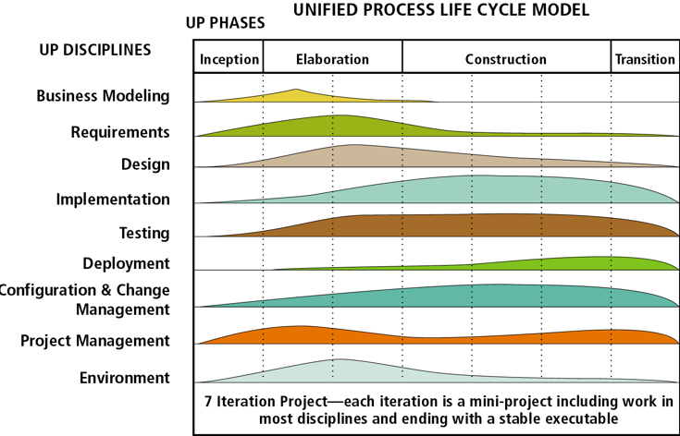

Figure 1: Unified Process Life Cycle Model.

The above diagram displayed the standard flow of implement SDLC in the project. The Unified Process phases are divided into four parts, Inception, Elaboration, Construction, Transition (Osis, J. and Donins, U., 2017).

Inception is the first and the shortest part of the project. Its function as requirement gathering including preparation of the business case, setting boundaries, identifying risks, etc.

Elaboration is the second phase which is expected to capture the remaining requirements. A Use-case diagram is generated in this phase.

The third phase is construction. It is the longest phase in the Unified Process to design, implement out the system functionality based on the requirement that is done during the elaboration phase.

The last phase is the transition phase. This is the final phase which releases the complete production version of the system to the customers (Khozaimi, Ach & Mulaab, & Rahim, Nailur., 2019).

**Project Planning**

During the life cycle, the first is to identify the idea and purpose to develop the system. This phase is aimed to identify the new scope of the system, develop a schedule (Gantt Chart) of the project, and the resource plan.

**Requirement Analysis.**

This is the second phase to initiate a project in Software Development Life Cycle. This phase emphasizes what is needed from the system. The product of this phase is the SRS (Software Requirement Specification). This is a document that describes the action performs of the project, and how it is going to be implemented (Krüger, N., 2018). The SRS must include the purpose of this system, a brief description, and identified specific requirement.

**Design**

After completion of the requirement analysis, is the design phase. This phase aims to develop the project structure and plan based on the requirement findings from the previous phase. The product of this phase is the SDD (Software Design Document). The SDD is different from the SRS at the previous state. The SRS describes what is the system function going to do while the SDD describes how is the system function is being implemented (Nuclino.com. 2019). Besides, the design phase includes identifying the language and package used to develop the system.

**Implementation**

The implementation phase is the coding phase which translates the design project plan into a real application and can be used at the production level.

**Testing**

This will be the last part of implementing the application. Every completed program code requires the testing method to avoid any bugs in the application. The test that is used is called UAT (User Acceptance Testing). This test is performed by the client to identify the goals of the project, whether it is matched with the requirement (Guru99.com. 2020).

**3.2 Incremental SDLC Model**

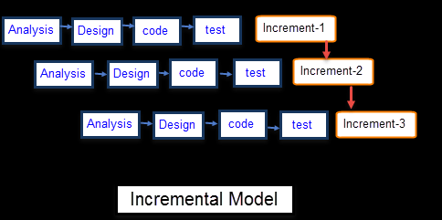

Figure 2: Incremental Model

The above figure showed the working flow of the incremental Model. The incremental model will divide the whole project into smaller parts and implement the SDLC model for each of the smaller parts. This model will start with a partially completed system and keep updating the new features slowly (Shah, Unnati S. and Jinwala, Devesh C. and Patel, Sankita J., 2016). Eventually, it becomes a complete system. This model is flexible and costs inexpensively because the project features can be changed during the development process, unlike the waterfall model which expensive to make changes due to the return unavailability linear structure. This project will use the concept of the incremental model if there is a new feature introduced into the system. This will carry out the standard project flow to analyze the feature

**3.3 UML Diagram**

UML (Unified Modeling Language) diagram is a visual graphical model to illustrate the project flow (Dobing, Brian & Parsons, Jeffrey., 2010). The UML is developed in the mid-1990s by combining the concept of object-oriented analysis and design (OOAD) approaches (Siau, Keng., 2010) and other modeling complex systems. UML's first version includes nine diagram models, which are class diagram, Object diagram, Component diagram, Deployment diagram, Use Case diagram, State-chart diagram, Activity diagram, Sequence diagram, and Collaboration diagram. UML's second version has introduced extra four modeling diagrams, which are Composite Structure diagram, Package diagram, Timing diagram, and Interaction Overview diagram (Booch, G., Rumbaugh, J., & Jacobson, I., 2005).

The diagram below shows the frequently used types of UML diagrams.

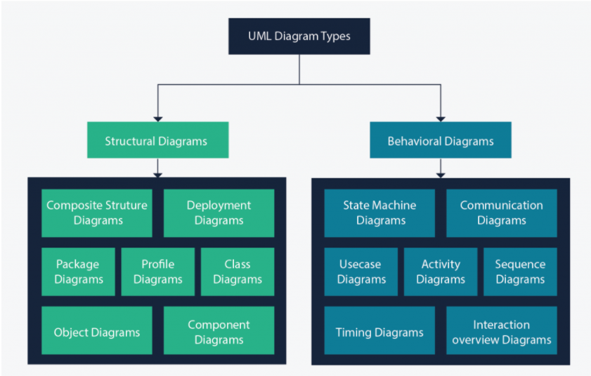

Figure 3: Types of UML Diagram

**3.3.1 Use Case Diagram**

Use Case diagram is a diagram that uses to illustrates the relationships between the actors and the functionality inside the system. Usually, a use case diagram only consists not more than 20 use cases in a diagram.

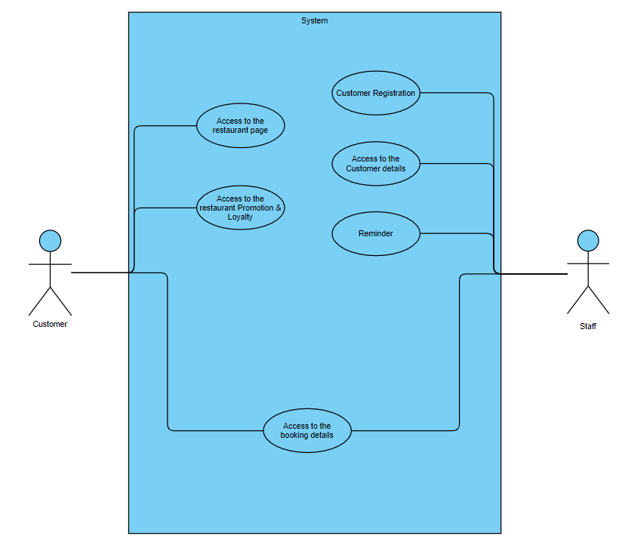

Figure 4: Use Case Diagram

This use case is related to two actors, the customer, and the staff. The customer can access the restaurant page to make reservation bookings directly to the restaurant. Besides, the customer can browse the current restaurant-organized promotion and loyalty reward items.

From the staff actor, It has three distinct use cases. First is customer registration. The staff can know the customer information details and his accumulated loyalty points. The staff will also send a reminder to the customers about their booking time and venue.

They will have the same use case which is browsing the booking details.

**3.3.2 Activity Diagram**

The Activity Diagram is crucial and fundamental to the UML software development flow diagram. Project planners using this activity to describe the system operation flow one by one in order to make the implementation design phase clearer and easier.

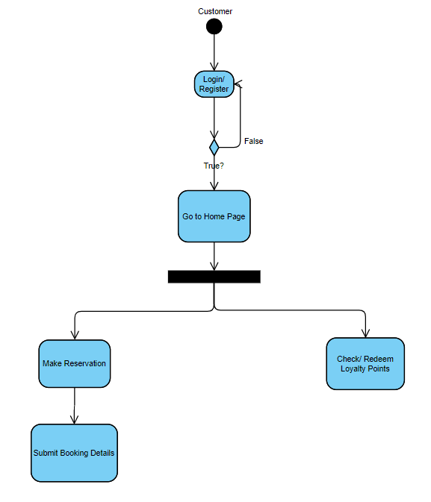The below diagrams illustrate the activity diagram in the project.

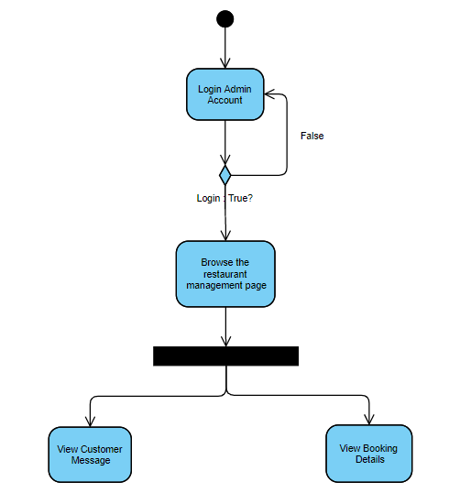

Figure 5: Customer Activity diagram

Figure 6: Restaurant Staff Activity Diagram

**3.4 Work Breakdown Structure (WBS)**

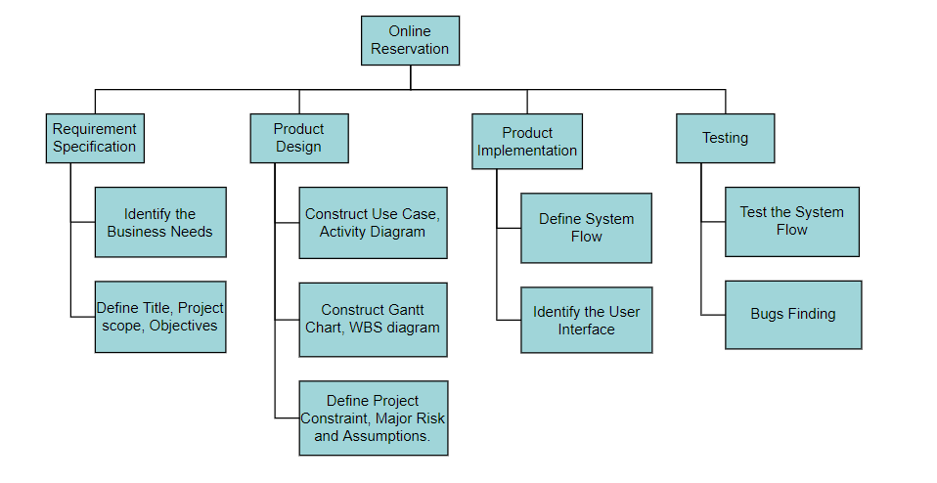

Figure 7: Work Breakdown Structure Diagram

1. WBS for Project Implementation
   1. Requirement Specification
      1. Identify the Business Needs
      2. Define Title, Project, Scope, Objectives
   2. Product Design
      1. Construct Use Case, Activity Diagram
      2. Construct Gantt Chart, WBS diagram
      3. Define Project Constraint, Major Risk and Assumptions
   3. Product Implementation
      1. Define System Flow
      2. Identify the User Interface
   4. Testing
      1. Test the System Flow
      2. Bugs Finding

**3.5 Gantt Chart == Major MileStone**

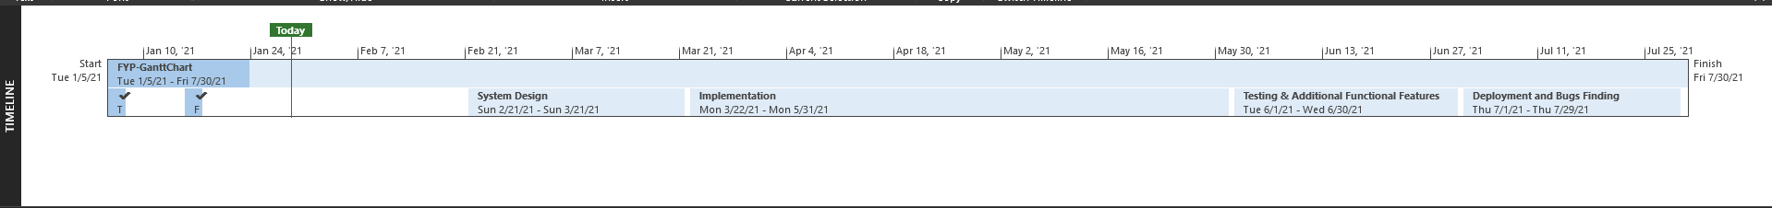

Figure 8: Project TimeLine.

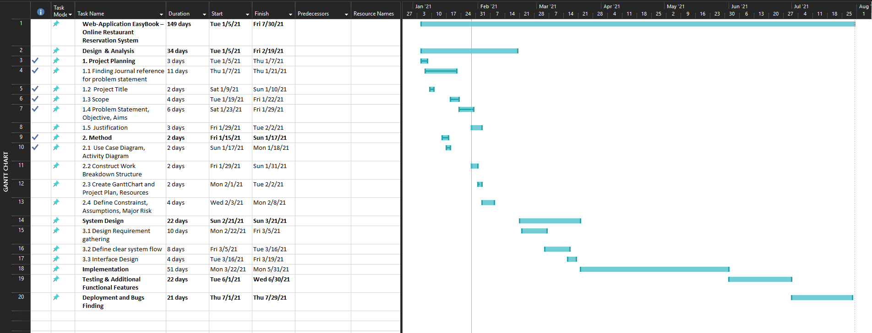

Figure 9: Project Gantt Chart

|  |  |  |  |
| --- | --- | --- | --- |
| Task Name | Duration | Start | Finish |
| **Web-application Easybook – Online Restaurant Reservation System** | **149 Days** | **Tuesday 1/5/2021** | **Friday 7/30/2021** |
| **Design & Analysis** | **34 Days** | **Tuesday 1/5/2021** | **Friday 2/19/2021** |
| 1. Project Planning | 3 Days | Tuesday 1/5/2021 | Thursday 1/7/2021 |
| 1.1 Finding Journal Reference for problem statement | 11 Days | Thursday 1/7/2021 | Thursday 1/21/2021 |
| 1.2 Project Title | 2 Days | Saturday 1/9/2021 | Sunday 1/10/2021 |
| 1.3 Scope | 4 Days | Tuesday 1/19/2021 | Friday 1/22/2021 |
| 1.4 Problem Statement, Objective, Aims | 6 Days | Saturday 1/23/2021 | Friday 1/29/2021 |
| 1.5 Justification | 3 Days | Friday 1/29/2021 | Tuesday 2/2/2021 |
| **2. Method** | **17 Days** | **Friday 1/15/2021** | **Sunday 2/8/2021** |
| 2.1 Use Case Diagram | 2 Days | Sunday 1/17/2021 | Monday 1/18/2021 |
| 2.2 Construct Work Breakdown Structure | 2 Days | Friday 1/29/2021 | Sunday 1/31/2021 |
| 2.3 Create Gantt Chart and Project Plan, Resources | 2 Days | Monday 2/1/2021 | Tuesday 2/2/2021 |
| 2.4 Define Constraints, Assumptions, Major Risk | 4 Days | Wednesday 2/3/2021 | Monday 2/8/2021 |
| **3. System Design** | **22 Days** | **Sunday 2/21/2021** | **Sunday 3/21/2021** |
| 3.1 Design Requirement gathering | 10 Days | Monday 2/22/2021 | Friday 3/5/2921 |
| 3.2 Define Clear System Flow | 8 Days | Friday 3/5/2021 | Tuesday 3/16/2021 |
| 3.3 Interface Design | 4 Days | Tuesday 3/16/2921 | Friday 3/19/2021 |
| **Implementation** | **51 Days** | **Monday 3/22/2021** | **Monday 5/31/2021** |
| **Testing & Additional Functional Features** | **22 Days** | **Tuesday 6/1/2021** | **Wednesday 6/30/2021** |
| **Deployment and Bugs Finding** | **21 Days** | **Thursday 7/1/2021** | **Thursday 7/29/2021** |

**3.6.1 Project Plan**

Figure 10: Project Plan

**3.7.1 Research Data Gathering and Analysis**

This project carried out a quantitative survey and using the Unified Theory of Acceptance and Use of Technology (UTAUT) model to generate the survey question in order to avoid generating bias questions. The reason I choose the UTAUT model as the theoretical model is that the UTAUT model is the reinforcement model to TAM (Technology Acceptance Model) model. TAM model has two determinants. There are ‘the intension of use’ and establish ‘the actual behavior to use’. The intention of use will lead people to use the application because they believe the application could improve their production. Perceived ease of use is to identify what is the cost the user needs to use the application (Marchewka, J. (2007)). To maintain the TAM model determinants, the UTAUT model integrates the structure of the intention of use and perceived ease of use through the performance expectancy and effort expectancy.

Figure 11: UTAUT model

UTAUT model identifies the Behavioral intention and uses behavior by observing and analyzing the influences of the individual differences including Gender, Age, Experience, and Voluntariness of Use perception.

**3.7.2 Research Questionnaire**

The questionnaire is done through the Google Form platform to gather the data and feedback. The questionnaire has five options provided for participants to choose whether they agree or disagree with the statement (Strongly disagree, Disagree, Neutral, Agree, Strongly Agree).

This questionnaire consists of two parts. The first section will be the demographic information and the second section will be the identification of the UTAUT influence (Onaolapo, S., & Oyewole, O. (2018)).

|  |  |
| --- | --- |
| **PE (Performance Expectancy): PE is used to identify how the individual trust that using this system will improve his job performance. PE focuses on task accomplishment and has been significantly influenced by Man.** | |
| PE01: | I would find EasyBook useful by booking a reservation table and pre-order menu. |
| PE02: | Through EasyBook I am able to enjoy the privilege of loyalty rewards while making reservation tables. |
| PE03: | I can book a table efficiently with the EasyBook application. |
| PE04: | The menu section information motivates me to use the EasyBook application. |
| PE05: | I believe using the EasyBook application can improve my reservation progress. |

Table 2: Performance Expectancy Evaluation

|  |  |
| --- | --- |
| **EE (Effort Expectancy): EE is used to investigate how to ease the system to be used and accepted by the individual.** | |
| EE01: | The use of the EasyBook application is not characterized by stress. |
| EE02: | I do not require much technical knowledge to use the EasyBook application. |
| EE03: | The use of the EasyBook application reduces cost, time, and effort. |
| EE04: | The use of the EasyBook application is not frustrating. |

Table 3: Effort Expectancy Evaluation

|  |  |
| --- | --- |
| **FC (Facilitating conditions): FC is used to find an influence on the usage of the application is important to help and support the organizations to manage the activity.** | |
| FC01: | The use of the EasyBook application is encouraged by the restaurant. |
| FC02: | Limited Internet connection and inadequate bandwidth in my university do not motivate me to use EasyBook. |
| FC03: | I find it very easy to use EasyBook for making reservation tables. |

Table 4: Facilitating Conditions Evaluation

**3.7.3 Hypotheses Development**

**H1:** Performance Expectancy positively influences user’s behavioral intention to adopt EasyBook

**H2:** Effort Expectancy positively influences user’s behavioral intention to adopt EasyBook.

**H3:** Facilitating conditions positively influence the user’s behavioral intention to adopt EasyBook.

Composite reliability (CR) and Cronbach’s α are used to calculate internal consistency reliability (Timmy H. Tseng, Shinjeng Lin, Yi-Shun Wang & Hui-Xuan Liu (2019)). Internal consistency reliability is a measurement to measure different items on the same test. It measures all the item’s variance to find the Cronbach’s alpha value in order to verify the result produces similar scores. Both CR and Cronbach’s α values are recommended to be greater than 0.7.

**Chapter 4 – Testing**

**4.1.1 Integration Testing**

Integration testing is to test the activity and fragments in the system to make sure all of them are runnable and functional to avoid app failure.

|  |  |  |  |
| --- | --- | --- | --- |
| Section | Class name/file | Method and descriptions | Workability |
| Authentication | Login.dart | onSubmit()  -To submit the email and password into the database so that the user can log in.  Validation()  -To validate the input field has content and matches the required pattern. | Working |
| Register.dart | onSubmit()  -To submit the email, name, and password into the database authenticate so that the user can register a new account and save a data record into the database.  Validation()  -To validate the input field has content and matches the required pattern. | Working |
| Forgotpassword.dart | resetPasswordWithEmail()  - Method will send an email to the registered account and they will get the chance to reset the password through the email | Working |
|  |  |  |  |
| Dashboard | Home.dart | onClick()  - This will allow users to navigate to different functions and pages.  CarouselOnPressed()  -Press on the carousel slider can view the detail of the information. | Working |
| Menu | MenuCategory.dart,  EditCategory.dart,  AddCategory.dart | FutureBuilder()  -load future menu category detail and display them on the page  onPressed()  -pressing the specific category, users will navigate into the food menu page  Add, Edit, Delete()  -Admin users will be allowed to add, edit, and delete the menu category on this page. | Working |
| Food List | FoodMenuList.dart,  EditFoodMenu.dart,  AddFoodMenu.dart | FutureBuilder()  -load future specific menu category food detail and display them on the page  onPressed()  -pressing the specific category, users will navigate into the food detail page.  Add, Edit, Delete()  -Admin users will be allowed to add, edit, and delete the food on this page. | Working |
| Food Detail | FoodDetail.dart | onClick()  -Users will redirect to the reservation page when clicking on the button | Working |
| Profile | Profile.dart | onClick()  -This page is the Profile dashboard page. Users can view the profile, change the setting here. | Working |
| Settings.dart | onClick()  -Users are allowed to change username, password, and email. | Working |
| Logout.dart | onClick()  -User will be log out and authenticate the account state will be erased. | Working |
| Loyalty Promotion  (Customer View) | CustomerLoyalty  Promotion.dart | StreamBuilder()  -The page will automatically get data from the database to display currently available promotions and redeemed vouchers.  onClick()  -To navigate the user to the reservation page and place a reservation order. | Working |
| CustomCardLoyalty  Point.dart | StreamBuilder()  -To browse current accumulated loyalty points. | Working |
| VoucherPromotion  Detail.dart | onClick()  -To view promotion voucher details. | Working |
| Loyalty Promotion (Admin View) | AdminLoyalty  Promotion.dart | StreamBuilder()  -Display all the currently available loyalty promotions on the dashboard.  onPress()  -To allow admin users to edit, add, and delete loyalty promotions.  -To allow admin users to navigate to the user voucher giveaway page. | Working |
| AddLoyalty  Promotion.dart | onSubmit()  -Submit the promotion data to the database and make it available to redeem in the application.  Validation()  -validate all fields to make sure that the content is correct | Working |
| EditLoyalty  Promotion.dart | onSubmit()  -Submit the edited promotion data to the database and make it available to redeem in the application.  Validation()  -validate all fields to make sure that the content is correct |  |
| UserVoucher  Giveaway.dart | onSubmit()  -Edit the first time user give away voucher information | Working. |
| Reservation  (Customer View) | Reservation  Dashboard.dart | onClick()  -To navigate the user to either the reservation page or reservation detail page | Working |
| OrderDetail.dart | StreamBuilder()  -To display ongoing reservation and reservation history.  onClick()  -To navigate user into the reservation detail page including ongoing reservation or reservation history. | Working. |
| TableReservation  .dart | SelectDate()  -To select booking date  SelectBookingSlot()  -To select a booking time slot.  SelectTable()  -To select the table  onSubmit()  -To save all the reservation data and navigate the user to the next section. | Working |
| preOrder.dart | onPress()  -To let the user pre-order the food, add it to the order cart.  FloatingActionButton()  -To allow users to check out the reservation booking. | Working |
| TotalCheckOut  Page.dart | SelectVoucher()  -Allow users to use the voucher redeemed from the loyalty promotion and make changes to the total price  onSubmit()  -Submit the reservation information and store it in the database. | Working. |
| Reservation  (Admin view) | AdminReservation  Dashboard.dart | FutureBuilder()  -To get the upcoming reservation and display on the page  Actions()  -allow admin users to generate the next seven days' reservation data.  onPress()  -Click on the specific reservation detail will navigate the admin into the detail reservation page. | Working |

* + 1. **Product Testing**

This product is developed based on Android Studio Emulator: Pixel 3a API 30 x86 which has a 440dpi screen resolution and is a 14Gb storage occupied device.

* + - 1. **Performance**

**Initial launching app:**

Figure 12: Initial Memory Usage

This app uses a little amount of memory to run the application and is ensure the application can run smoothly on most of the devices. It can maintain a 60 frames refresh rate per second through the app.

Opening Menu Food Detail page:

Figure 13: Memory Usage on Food Detail Page

When the application is navigated into the food menu page which has stacked several pages, it only used 66.3MB of memory at most.

Complete Reservation Booking:

Figure 14: Reservation Booking Memory Usage

Conducting the most complex progress in the application which is reservation booking action, the application only uses 71MB memory of the device and is working smooth and quick.

**4.1.3 User Acceptance Test**

This survey has been conducted through the UTAUT model. This survey aims to test user acceptance of the Easybook application and find out which part can be improved in future development. This study is carried out at UCSI University and took about 15 respondents to take part in this survey.

Throughout the survey, there is 80% of the responses are aged range 20 to 24, and 20% of the responses are around 15 to 19. 66.7% of the respondents are Male and 33.3% are Female.

Cronbach’s alpha (α)

The formula used to find Cronbach's alpha value is:

Figure 15: Cronbach’s Alpha Formula

To find Cronbach's alpha value, first should find every question’s variance.

Figure 16: Variance formula

**Performance Expectancy section:**

|  |  |
| --- | --- |
| Question | Variance |
| 1 | 0.3075 |
| 2 | 0.4359 |
| 3 | 0.2571 |
| 4 | 0.5524 |
| 5 | 0.5524 |

Table 5: Performance Expectancy variance

The variance of the Performance Expectancy Section is: 10.2571



Figure 17: Total Column Variance of Performance Expectancy

The Cronbach’s alpha value of the Performance Expectancy is:

a = ( 5 / 4) ( (10.2571 – 2.1053) / 10.2571),

a = 0.9934

Fulfill the minimum acceptance requirement.

**Effort Expectancy section:**

|  |  |
| --- | --- |
| **Question** | **Variance** |
| **1** | **0.3075** |
| **2** | **0.4** |
| **3** | **0.3810** |
| **4** | **0.4** |

Table 6: Effort Expectancy variance

**The variance of the Effort Expectancy: 5.8095**



Figure 18: Total Column Variance of Effort Expectancy

The Cronbach’s alpha value of the Performance Expectancy is:

a = ( 4 / 3) ( (5.8095 – 1.4885) / 5.8095),

a = 0.9917

Fulfill the minimum acceptance requirement.

**Facilitating Conditions section:**

|  |  |
| --- | --- |
| **Question** | **Variance** |
| **1** | **0.4095** |
| **2** | **1.3523** |
| **3** | **0.8381** |

Table 6: Effort Expectancy variance

**The variance of the Facilitating Conditions: 6.9238**



Figure 19: Total Column Variance of Facilitating Conditions

The Cronbach’s alpha value of the Performance Expectancy is:

a = ( 3 / 2) ( (6.9238– 2.5999) / 6.9238),

a = 0.9367

Fulfill the minimum acceptance requirement.

Based on the above result, this application has been accepted by most UCSI students and it is believed that this application will give aid to the restaurant and customer in order to pull closer the relationship.

**Chapter 5 – Prototyping Interface**

The app has been developed through flutter platform-based Dart language.

**Login & Register Dashboard**

Figure 20: Login Page Figure 21: Register Page Figure 22: Forgot Password

The combination of three pages constructed the login & register section, which are Login Page, Register Page, and Forgot password page. Login Page consists of a clear title above the background picture and states “Login” which indicates that this is the login page. Users who already granted an account can use the email and password that are registered to log into the system. Next, at the top-right position, there is a button named “Register”. This button will redirect the user to Register Page and allows the user to register a new account.

Inside the Register page, the new user is required to enter their username, email, and password. There is a text field provided to the user to double confirmed his password to avoid typo errors. If the user does not want to register a new account, he can press the back button at the top-left corner to back to the Login Page or the back button at the bottom provided by the Android system.

If the registered user forgot the password he set during the registration, there is a text button that allows the user to reset his account password. The user is required to enter his registered email and he will get a link to reset his account password.

Figure 25: Forgot Password Error Handling

Figure 24: Register Error Handling

Figure 23: Login Error Handling

According to Shneiderman’s Eight Golden Rules, a specific rule is named “offer informative feedback”. Therefore, it will apply to the login & registration section. Login Page, Register Page, and Reset Password Page have an error handling feature, these features are validated by different rules. For example, email is checked by Regular Expression to ensure that the email is having a correct format before submitting it to the backend. A clear error message will be shown under the text field so that the user can easily know where is going wrong.

**Home Dashboard**

Figure 27: Carousel Slider Effect

Figure 26: Home Dashboard

Inside the Dashboard page, there is an app bar title telling welcome speech. Below the title, the content body is constructed by two components. The first component is a carousel slider component that displays the current promotion, menu, and specific discount. Users can check what is the newest menu item and promotion discount by tap into the picture. The second component displays the options to navigate to different functions. First is the reservation function, second is the menu page, third is loyalty promotion, and lastly is the user profile.

**Menu Page**

**Menu Category Section**

First will show about the menu page. The user will be redirected to the menu dashboard when pressed the Menu button.

Figure 30: Edit Category

Figure 29: Add Category

Figure28: Menu Dashboard

Menu dashboard first shows the food category types. This is the design layout for the admin account which allows the admin to add a new category, edit the category, and delete a category. Inside Add Category page, the admin must specify the title of the category, its respective category description, but must not be too long to avoid destroying the card design, and an image to represent the category type. Edit category performs almost the same functions as add category did, but instead of creating a new category, it edits the current category database.

**Food List Section**

Figure 33: Edit Food Menu

Figure 32: Add Food Menu

Figure 31: Food List Dashboard

When the user clicks into any one of the categories, the food list will load and render the food details on the food list page. The functions provided in this section are similar to the menu category section and are only provided to the account with the “admin” specification.

**Food Details Page**

Figure 34: Food Detail Page

On this page, the user will get the specific food detail and their price. Next, if the user wants to directly make a reservation, he can press the green button and will navigate the user to Reservation Page.

**Profile Section**

Figure 36: Settings Page

Figure 35: Profile Dashboard

In the Profile dashboard, the user will first see his name and the accumulated loyalty point from purchased history. After that is the short form circle avatar of the user. The user has three functions to perform on this page: settings, about, and log out. The settings function allows the user to change his account profile information. About Page allows the user to view the current application version and acknowledgment. Log out to log out the user.

Inside the Setting page, the user is allowed to change the username, email, and password. Since the account does not require other information, for example, phone number and third party sign-in method. Therefore user only allows modifying these three settings.

**Settings Modification Section**

Figure 39: Change Email

Figure 38: Change Password

Figure 37: Change Username

The modification section page will have a similar design view as the Login and Register page. This is to let the user to familiar with the design so that they will not felt lost when getting into this section. All the text field has come along with the hint text to tell the user what content should fit into the text field. Besides, the text field also comes with a set of validation methods to check whether the content is valid or not.

About Page

Figure 40: About Page

This is the about page. Let the user understand the version of the application.

**Loyalty Promotion Section. (Admin Side)**

Figure 43: Error Handling

Figure 42: Set New User Giveaway Voucher

Figure 41: Loyalty Promotion Admin Dashboard

When the admin clicks on the Loyalty Promotion button, the system will redirect him into Admin Loyalty Promotion Dashboard. This dashboard is specifically available for the admin account. The admin first will see the currently available promotion saved in the system. Admin can modify the promotion information and also delete the promotion. On the top-right of the application bar, there is an icon button that will pop up a modal that allows the admin to adjust the new user giveaway voucher. This voucher will be given to the user once they signed up for a new account. This modal comes with an error-handling form feature to validate the content of the text field.

**Edit page**

Figure 44: Edit Promotion

This edit page allows the admin to modify the currently available voucher details. It contains the title, description, expired date, discount percentage, and loyalty point required section.

The end of the page has a button to let the admin add a new promotion.

Figure 46: Error Handling

Figure 45: Add Promotion

This page provides five sections to input. Title, Description, expired Date that handles the voucher expired date, discount percentage which will make a discount on the total bill, and loyalty point required when redeeming the voucher.

This add promotion page also comes with an error-handling message so that the admin will know where is wrong.

**Loyalty Promotion Dashboard (Common User Side)**

Figure 47: Customer Loyalty Dashboard

Figure 48: Customer Loyalty Dashboard (cont.)

In this section, the common user will browse the loyalty promotion information. First, the user can see his name appear on the page. A “Book Now!” text button is placed under the name to allow the user fast navigate to the reservation page. In the middle of the page, the user can get his current accumulated point from the reservation made before. The user can use this point to redeem the voucher promotion and apply it when he makes a reservation booking.

Below the point card, there is a horizontal scroll list view to show all the promotions currently available to be redeemed. This specific list tile item contains a promotion title, its description, a percentage of discount, and guidance to navigate to the promotion details page.

The bottom section, here will display the user redeemed voucher. The user can see what voucher he already redeemed.

**Promotion Detail**

Figure 50: Redeem Successfully

Figure 51: Redeem Failed

Figure 49 : Voucher Detail

In this section, users can view the promotion information, its expired date, discount percentage, and loyalty point required to redeem. If the user has enough loyalty points to redeem the voucher, a snack bar will appear on the screen said redeem successfully, otherwise display the error message said that the possible error occurs.

**Reservation Section (Customer Side)**

Figure 52: Reservation Dashboard

**Reservation Detail Page (Customer Side)**

Figure 54: Specific Detail Page

Figure 53: Reservation Detail Page

This section allows the user to view his current reservation and post-reservation detail. It will show the reservation table number, booking time and date, and its preorder food cost information. Users can know the booking time and table directly from this view. Besides, the user can cancel his reservation by clicking the delete button. A pop-up modal will show to double confirm with the user to cancel the booking. To view more specific information about the specific reservation. The user can click on the card design and it will navigate to the detail page.

**Reservation Booking Page (Customer Side)**

Figure 55: Reservation Booking Page

Figure 56: Status Changed

On this page, the user will first see the select date option. The date will be the current date if the current available time is still greater than the current date hour. If the current date hour is greater than the current available time, the select date will jump to the next date. Besides, the user is not allowed to select the past date and time.

Next, the user can select the table to make the reservation booking. If the table has been booked by another user, the table status will change to Closed and become unselectable.

**Pre Order Page (Customer Side)**

Figure 58: Pre Order Food Page

Figure 57: Pre Order Menu Page

After the user clicked the submit button, he will be redirected to the Pre Order Menu page. The user can browse the food menu category here and pick the food he wants to pre-order. There is a floating action button at the top-right corner under the app bar to let the user sum all the orders and go to the submit page. The user can choose whether to submit the order without adding any food or not. If the user selects one of the categories, he will enter into the Pre Order Food page. This Pre Order Food page allows users to add the food item into the pre-order cart and the restaurant staff will know what food the user wants. For each food item, two buttons are given to the user to perform an action. First is the increment button to add a food item into the cart. The second is the delete button, which allows the user to remove the food from the pre-order cart.

**Check Out Cart Section (Customer Side)**

Figure 59: Check Out Cart Page

Figure 60: Full Details

This is the check-out cart page. First, the section will show the reservation details including who is making the reservation, the table number, booking date, and the booking time. Next, the order details section consists of the menu ordered by the customer with the price and a delete icon. The delete icon allows the user to delete the menu item. This system also provides a comment text field that allows the user to tell the restaurant staff about extra requirements.

Before confirming the order, the user can select whether to use the voucher redeemed from the loyalty promotion or not. If the user wants to use the voucher, it can pick the voucher from the dropdown menu and the selected voucher will make changes to the total price. A small hint text was also provided to indicate that the price is after discount.

**Confirmation Booking Page (Customer Side)**

Figure 61: Confirm Page

**Reservation Booking Page (Admin Side)**

Figure 64: Reservation Detail Page

Figure 63: Add Reservation Table

Figure 62: Admin Reservation Page

This reservation page is only for admin. Admin can view all the upcoming reservation details here. Besides, the admin must use the top-right corner plus icon to create the table for every seven days. This button will pop up a modal and ask the admin to fill in how many tables he wants to create. By clicking into the specific list tile reservation. The complete reservation detail will be shown on the screen and the admin can know who booked the table and what is the comment given by the user. If the reservation has a comment, a message icon will be shown beside the arrow to indicate that this is a reservation with a comment. The admin does not need to open every reservation to check the reservation comment.

**Database Demonstration**

This project uses firebase as a database to handle the data transaction of the application. This project will use firebase authentication and firebase cloud database (in short firestore). Firebase authentication provides different authentication methods to allow a user to register and login into the application. This application only enables the email and password login method.

Figure 65: Firebase Authentication

**Firebase Cloud Firestore**

**User Collection**

When the user registers an account through the app, a user data record will be store in the firestore. This record will also append the user roles and the user loyalty point. Besides, this data collection also includes the voucher sub-collection which contains the user redeemed voucher.

Figure 67: Voucher Sub-collection

Figure 66: Member Collection

**Menu Collection**

To store menu category and food details data, an account with a user type of admin will be able to create menu category collection and its respective food details data. In the app, the menu section will load the menu category and food detail from this collection.

Figure 68: Menu Category Collection

Figure 69: Food Detail Collection

**Loyalty Promotion Collection**

This collection will store the data about the discount voucher. All the discount voucher information including the title, description, and discount percentage will be stored here. The normal user will get to view the voucher details and they can choose to redeem the voucher or not.

Figure 70: Loyalty Promotion Collection

Besides, the admin user type can reset the new user voucher details. This voucher will be given to the user who just registered for the app.

Figure 71: New User Voucher Collection

**Table Reservation Collection**

This collection will consist of all the table reservation detail. This will allows the user to get the next seven days' reservation table data.

Figure 73: Table Reservation Collection

Figure 72: Table Reservation Collection

Figure 73: Table Reservation Detail Collection

**Reservation Detail Collection**

This reservation detail collection is created when there is a user makes a reservation booking through the application. This will store all the information including booking date, customer name, pre-order menu, and comment. The admin will need this collection to get all the ongoing reservation detail so that they can manage the order neatly.

Figure 74: Reservation Detail Collection

**Order Detail Collection**

Order detail collection specifically works for the customer user account. The customer who logs into the account can view their reservation detail through this collection.

Figure 76: Order Detail Collection

Figure 75 : Order Detail Collection

**Chapter 6 – Discussion / Conclusion**

**6.1 Conclusion**

Nowadays, the smartphone has become necessary equipment for every modern city people in order to perform daily tasks including online communication, handling job issues, and entertainment. It is believed that online reservation will be a future trend for all of the society around the world because humans tend to get convenience to complete a thing. By using EasyBook online reservation system, the user can easily reserve a place to enjoy his meal, the organizer can easily track the reserved details and well-handled management flow of the restaurant.

**6.2.1 Future Development**

Although most of the objectives have been achieved. However, there are still some unsatisfactory parts that could be improved. The system design is simple and crude, this system will implement more features in the future and make the design layout clear and useful. The menu detail is still lacking some information content which will be improved in the future.

The chat system between the restaurant staff and the customer in order to provide a more detailed conversation between the staff and the customer. Besides, a notification message will be implemented soon in the next version to notify a user about his upcoming reservation booking.

**6.2.2 Contribution to Society**

By using this system, the user does not need to spend more time making a phone call just to reserve a table. They do not need to worry about the loss of reservation booking information. All the data will be transferred into the database quickly and safely. Besides, the user can track restaurant detail through the application and see whether the restaurant table is available or not.

From the admin side, the admin can make changes to the system features. For example, edit menu category, edit food item, edit loyalty promotion voucher, etc… They can perform all the tasks in the application and this operation could save time consumption.

**5.0 References**

[1] Christensson, P. (2006). WWW Definition. Retrieved 2021, Jan 17, from https://techterms.com

[2] Aghaei, S., Ali Nematbakhsh, M. and Khosravi Farsani, H., 2012. Evolution of the World Wide Web : From Web 1.0 to Web 4.0. International journal of Web & Semantic Technology, 3(1), pp.1-10.

[3] Mata, F. and Quesada, A., 2014. Web 2.0, Social Networks and E-commerce as Marketing Tools. Journal of theoretical and applied electronic commerce research, 9(1), pp.11-12.

[4] World Stats, I., 2021. World Internet Users Statistics And 2020 World Population Stats. [online] Internetworldstats.com. Available at: <https://www.internetworldstats.com/stats.htm> [Accessed 18 January 2021].

[5] Ward, H., 2020. Smartphone Users In Malaysia 2017-2023 | Statista. [online] Statista. Available at: <https://www.statista.com/statistics/494587/smartphone-users-in-malaysia/> [Accessed 18 January 2021].

[6] Kuo-Lun Hsiao, Yu Shu, Tien-Chi Huang (2017), Exploring the effect of compulsive social app usage on technostress and academic performance: Perspectives from personality traits, Telematics and Informatics, Volume 34, Issue 2, Pages 679-690,

[7] IQBAL, M. (2021). App Download and Usage Statistics (2020). Retrieved 1 July 2021, from https://www.businessofapps.com/data/app-statistics/

[8] H Ivanov, S., 2008. Conceptual Marketing Framework for Online Hotel Reservation System Design. SSRN Electronic Journal, 1(1), pp.1 - 43.

[9] Resendes, S., 2020. 50+ Restaurant Industry Statistics Restaurateurs Should Know In 2020. [online] Restaurant Insider. Available at: <https://upserve.com/restaurant-insider/industry-statistics/> [Accessed 18 January 2021].

[10] ResDiary. 2020. Moving To An Online Reservation System: A Case Study | Resdiary. [online] Available at: <https://sales.resdiary.com/moving-online-reservation-system/> [Accessed 19 January 2021].

[11] Maadh, A. and Rajasvarann, L., 2020. Web-Based Ferry Booking System With Live Location Ttracking. Journal of critical reviews, 7(03), pp.110-113.

[12] Prof. Parvati, B., 2020. Restaurant Table Reservation using Graphical Representation. International Research Journal of Engineering and Technology (IRJET), 7(1), pp.2049-2051.

[13] Tiffanynight. 2017. Disadvantages Of Online Booking Systems - Tiffanynight. [online] Available at: <https://www.tiffanynight.com/online-booking-systems/> [Accessed 19 January 2021].

[14] Schaarschmidt, M. and Höber, B., 2017. Digital booking services: comparing online with phone reservation services. Journal of Services Marketing, 31(7), pp.704-719.

[15] Gerber, C., Ward, S. and Goedhals-Gerber, L., 2014. The impact of perceived risk on on-line purchase behaviour. Risk Governance and Control: Financial Markets and Institutions, 4(4), pp.99-106.

[16] Kleijnen, M., De Ruyter, K., and Wetzels, M., 2007. “An assessment of value creation in

mobile service delivery and the moderating role of time consciousness,” Journal of Retailing,

Vol 83 No. 1, pp. 33-46.

[17] Koufaris, M. and Hampton-Sosa, W., 2004. The development of initial trust in an online company by new customers. Information & Management, 41(3), pp.377-397.

[18] Kwek, C. and Dazmin, b., 2011. Perceived Risk, Perceived Technology, Online Trust for the Online Purchase Intention in Malaysia. International Journal of Business and Management, 6(6), pp.167-182.

[19] Jang, Dongsuk & Mattila, Anna., 2005. An examination of restaurant loyalty programs: What kinds of rewards do customers prefer?. International Journal of Contemporary Hospitality Management. 17. 402-408

[20] Kim, J.J., Steinhoff, L. & Palmatier, R.W., 2021. An emerging theory of loyalty program dynamics. J. of the Acad. Mark. Sci. 49, 71–95

[21] Aldaihani, Faraj & Ali, Noor., 2018. Factors Affecting Customer Loyalty in the Restaurant Service Industry in Kuwait City, Kuwait.

[22] Yasuda, G., 2018. How To Nurture Restaurant Loyalty: The Key Role Of POS Technology. [online] Oracle Food and Beverage Blog. Available at: <https://blogs.oracle.com/foodandbeverage/how-to-nurture-restaurant-loyalty-pos-systems> [Accessed 24 January 2021].

[23] Wayman, C., 2020. Loyalty Vs. Promotion: What’S The Difference? | Blog | Merkle. [online] Merkle. Available at: <https://www.merkleinc.com/blog/loyalty-vs-promotion-whats-difference> [Accessed 24 January 2021].

[24] Sdn Bhd, Z., 2021. Difference Between Sales Promotion And Loyalty Rewards. [online] ELOYALTYAPP. Available at: <https://www.eloyaltyapp.com/difference-between-sales-promotion-and-loyalty-rewards/> [Accessed 24 January 2021].

[25] Sin, M. and Butler, L., 2018. Restaurant Loyalty Programs: Are they worth the investment?. Kellogg Honors College Capstone Project, 1(1), p.1.

[26] DAH, Helen Mavis, CHEN, Wei and PREMPREH, Vida Minta, 2015. Assessing the Impact of Loyalty Program on Consumer Purchasing Behavior in Fine-Dining Restaurant. Journal of Business and Management, 7 (30).

[27] Ali M. Shah, Syed Zeeshan Zahoor, Ishtiaq Hussain Qureshi., 2019. Social Media and Purchasing Behavior: A Study of the Mediating Effect of Customer Relationships. Journal of Global Marketing 32:2, pages 93-115.

[28] UCSI University Object-Oriented Modeling, 2020. Object-Oriented Modeling Lecture Slide Chapter 2. p.1-24.

[29] Kumar Dora, S. and Dubey, P., 2013. Software Development Life Cycle (SDLC) Analytical Comparison And Survey On Traditional And Agile Methodology. National Monthly Refereed Journal Of Research In Science & Technology, 2(8), pp.22-30.

[30] Noll, John & Abdur, Razzak & Bass, Julian & Beecham, Sarah., 2017. A Study of the Scrum Master’s Role. 307-323. 10.1007/978-3-319-69926-4_22.

[31] Osis, J. and Donins, U., 2017. Chapter 2 - Software Designing With Unified Modeling Language Driven Approaches,. Computer Science Reviews and Trends, Topological UML Modeling, 2(2), pp.53-82.

[32] Khozaimi, Ach & Mulaab, & Rahim, Nailur., 2019. Adapting Unified Process Model Approach in Designing Application for Research Data Governance. 9. 21274-21277.

[33] Krüger, N., 2018. How To Write A Software Requirements Specification (SRS Document) | Perforce Software. [online] Perforce Software. Available at: <https://www.perforce.com/blog/alm/how-write-software-requirements-specification-srs-document> [Accessed 27 January 2021].

[34] Nuclino.com. 2019. How To Write A Software Design Document (SDD). [online] Available at: <https://www.nuclino.com/articles/software-design-document> [Accessed 27 January 2021].

[35] Guru99.com. 2020. What Is User Acceptance Testing (UAT)? With Examples. [online] Available at: <https://www.guru99.com/user-acceptance-testing.html> [Accessed 27 January 2021].

[36] Shah, Unnati S. and Jinwala, Devesh C. and Patel, Sankita J., 2016. An Excursion to Software Development Life Cycle Models: An Old to Ever-Growing Models. Association for Computing Machinery. 41(1). pp.1-6.

[37] Booch, G., Rumbaugh, J., & Jacobson, I., 2005. The Unified Modeling Language user guide second edition.

[38] Siau, Keng., 2010. An Analysis of Unified Modeling Language (UML) Graphical Constructs Based on BWW Ontology. Journal of Database Management. 21.

[39] Dobing, Brian & Parsons, Jeffrey., 2010. Dimensions of UML Diagram Use. Journal of Database Management. 19. 1-18.

[40] Ahmad, Tanwir & Iqbal, Junaid & Ashraf, Adnan & Truscan, Dragos & Porres, Ivan., 2019. Model-based testing using UML activity diagrams: A systematic mapping study. Computer Science Review. 33. 98-112.

[41] Lim, E., Ooi, C., Ooi, S., Ooi, Y. and Tan, M., 2014. Customer loyalty: A study on newly opened cafés and restaurants in Penang. Journal of Foodservice Business Research, 20(5), pp.1-116.

[42] Marchewka, J. (2007). An Application of the UTAUT Model for Understanding Student Perceptions Using Course Management Software. Communications Of The IIMA, 7(2), 93 - 104.

[43] Onaolapo, S., & Oyewole, O. (2018). Performance expectancy, effort expectancy, and facilitating conditions as factors influencing smart phones use for mobile learning by postgraduate students of the University of Ibadan, Nigeria. Interdisciplinary Journal of e-Skills and Lifelong Learning, 14, 95-115.

[44] Timmy H. Tseng, Shinjeng Lin, Yi-Shun Wang & Hui-Xuan Liu (2019) Investigating teachers’ adoption of MOOCs: the perspective of UTAUT2, Interactive Learning Environments

[45] Islam, Dr. MD Rashedul & Mazumder, Tridib. (2010). Mobile application and its global impact. International Journal of Engineering & Technology. 10. 72-78.

[46] Karczewski, D. (2020, September 14). Flutter App Development: Everything You Need to Know in 2021. https://www.ideamotive.co/blog/flutter-app-development-everything-you-need-to-know

[47] Idan Arb, G., & Al-Majdi, K. (2020). A Freights Status Management System Based on Dart and Flutter Programming Language. Journal of Physics: Conference Series, 1530

**Appendix A**

Turnitin Report

Variance data of Question:













Survey Questionnaire:

Section 1: Basic Information gathering

Question 1: Age

Question 2: Gender

Question 3: Education Level

Section 2: Performance Expectancy Data Collection

Question 1: PE01: I would find EasyBook useful by booking a reservation table and pre-order menu.

Question 2: PE02: Through EasyBook I am able to enjoy the privilege of loyalty rewards while making reservation tables.

Question 3: PE03: I can book a table efficiently with the EasyBook application.

Question 4: PE04: The menu section information motivates me to use the EasyBook application.

Question 5: PE05: I believe using the EasyBook application can improve my reservation progress.

Section 3: Effort Expectancy Data Collection.

Question 1: EE01: The use of the EasyBook application is not characterized by stress.

Question 2: EE02: I do not require much technical knowledge to use the EasyBook application.

Question 3: EE03: The use of the EasyBook application reduces cost, time, and effort.

Question 4: EE04: The use of the EasyBook application is not frustrating.

Section 4: Facilitating Conditions Data Condition

Question 1: FC01: The use of the EasyBook application is encouraged by the restaurant.

Question 2: FC02: Limited Internet connection and inadequate bandwidth in my university do not motivate me to use EasyBook.

Question 3: FC03: I find it very easy to use EasyBook for making reservation tables.